EDITABLE RESOURCES
PROGRAMME ALIGNEMENT TRANSFORMATIVE LEARNING
COURSE REDESIGN LEARNING DESIGN

COURSE REDESIGN

TRANSFORMHE.ORG

This toolkit has been developed by the Transforming Employability for Social Change in East Africa (TESCEA) partnership.

Authors: Mary Omingo, Annelise Dennis, Mai Skovgaard
With contributions from: Kendi Muchungi, Joanna Wild, Beth Wokabi, Jennifer Chapin

Acknowledgements:

The TESCEA partnership is a consortium of seven organisations from four countries, Mzumbe University, University of Dodoma, Gulu University, Uganda Martyrs University, AFELT, Ashoka East Africa and INASP.

The TESCEA project (2018-2021) was part of the Strategic Partnerships for Higher Education Innovation and Reform (SPHEIR) programme. SPHEIR is funded by the UK Foreign, Commonwealth
& Development Office (FCDO) and is managed on behalf of FCDO by a
consortium led by the British Council that includes PwC and Universities UK International.

TRANSFORMHE.ORG

Contact: TransformHE@inasp.info
We are grateful to all those who have contributed to the evolution and development of our toolkit for Course Redesign. Particular thanks go to the AFELT team members
and multipliers and facilitators of learning at Mzumbe University, University of Dodoma, Gulu University and Uganda Martyrs University who co-facilitated, participated in and provided feedback on the course redesign workshops during the TESCEA project.

Particular thanks also go to Simon Fraser University for allowing us to use, build on and adapt their course redesign materials for the purposes of TESCEA and this toolkit, and to the Quality, Teaching and Learning Network at Aga Khan University. Thank
you to all the organisations and individuals who have granted permission for reuse of copyrighted material for the purpose of this toolkit.

Finally, we would also like to thank Charlotte Nussey who consulted on the development of our framework for gender-responsive pedagogy.

Editing and proofreading by: Siân Harris, Sophie Gillespie
Page setting by: Steven Dickie
Design: squarebeasts.net

© INASP 2021 (on behalf of the TESCEA partnership), unless stated otherwise.

This work is licensed under a Creative Commons Attribution-NonCommercial-ShareAlike 4.0 International license. Trainers are encouraged to reproduce material from this toolkit for their own training and publications under the same conditions as the materials are made available. This license does NOT extend to third-party content, text or images, that has been cited. Please contact the original authors of any third-party content if you wish to reuse or adapt.

DAY 1 ADDITIONAL FACILITATION GUIDANCE & VISUAL AIDS: CONCEPT MAPPING

Concepts or Topics sorting and categorising activity

SESSION: AN INTRODUCTION TO THE COURSE REDESIGN WORKSHOP AND CONCEPT MAPPING

Note to workshop facilitator:

Print out the words, on the next page, on paper or card (of one colour). The number of words depends on how much time you have for this activity. The activity is conducted in groups of three to four participants, so make sure that each group has one set of the printed words.
Next, cut out each word and shuffle them so the concepts and topics are well mixed. You may want to get them laminated so that they can be reused in future workshops.
A suggested answer key is provided directly below:

CONCEPTS | TOPICS
Systems | Solar System
Choice | Internet
Imagery | Ancient Egypt
Identity | Maasai
Diversity | Biological cells
Perspective | Airports
Adaptation | Animal adaptation
Relationships | Statistics
Beliefs | Changing gender roles in Mauritius

CONCEPTS | TOPICS
Systems | Biological Cells
Choice | Animal adaptation
Imagery | Ancient Egypt
Identity | Statistics
Diversity | Maasai
Perspective | Changing gender roles in Mauritius
Adaptation | Airports
Relationships | Internet
Beliefs | Solar System

DAY 2 ADDITIONAL FACILITATION GUIDANCE & VISUAL AIDS: LEARNING OUTCOMES

Handout: Key points from 4Cs debrief of compulsory reading: TSL

SESSION: COMPULSORY READING: TAXONOMY OF SIGNIFICANT LEARNING (TSL)

Note to workshop facilitator:

Customise this handout by deleting the top heading and these instructions.
This handout is also available separately in the Course Redesign section of TransformHE.org. Print enough handouts for each participant and hand them out to each participant towards the end of the compulsory reading session.

CONNECTIONS

There is a connection between the Taxonomy of Significant Learning (TSL) and Bloom’s Taxonomy in that the foundational knowledge aligns with Bloom’s cognitive domain. However, educators (or, in our case, facilitators of learning) mainly concentrate on the cognitive domain and leave out the
psychomotor and affective domains as outlined in Bloom’s Taxonomy. Fink explains explicitly the two domains in terms of the application dimension (the psychomotor domain) and human dimension, caring and learning how to learn (the affective domain)
There are connections to the previous reading from day 1, How people learn. Both readings stress the importance of students learning factual knowledge but within a conceptual framework/structure and the need for learning to go beyond simply the mastery of content.
You, as a facilitator of learning, can also identify what connections exist between the points in the text and your own life.

CHALLENGES

Some subjects easily lend themselves to having learning outcomes on the human dimension, caring, and learning how to learn dimensions. At times, these three are integrated in learning outcomes that address the foundational knowledge, application, and integration dimensions. It may sometimes be easier for facilitators of learning to integrate the human dimension, caring, and learning how to learn dimensions into the teaching and learning strategies rather than to write standalone learning outcomes that explicitly refer to these three dimensions.
Some of the learning outcomes in the geography unit (in the compulsory reading) have words such as understand and know, which are not measurable. This might appear a bit confusing and contradictory. It is important to reiterate that there is a need to use verbs that are measurable and to avoid the use of words such as understand, know, think and comprehend (as previously discussed on Day 1).

CONCEPTS

Taxonomy of significant learning. See figure 2.1 Taxonomy of significant learning, for the six dimensions (or kinds) of learning: foundational knowledge, application, integration, human dimension, caring, and learning how to learn, in a circular form instead of hierarchical as in Bloom’s taxonomy.
Interactive nature of the six dimensions (or kinds) of learning. See figure 2.2.

Content-centred vs Learning-centred. A paradigm shift from content-centred to learning-centred. In content-centred approaches lecturers are challenged by the question of how much of the traditional and additional topics they can cover in the time available. In learning-centred approaches where facilitators of learning respond to the question of what students should learn by describing the different kinds (or dimensions) of learning: foundational knowledge, application, integration, human dimension, caring, and learning how to learn.
The learning-centred paradigm is about facilitators of learning paying particular attention to important content, leading them to incorporate new dimensions (or kinds) of learning rather than simply adding new content. See Figure 2.4. The Effects of Two Different Paradigms.

CHANGES

Incorporate all of the six kinds (or dimensions) of learning in your students’ learning, as learning goes way beyond the mastery of content.
The need to include the human dimension, caring, and learning how to learn dimensions in the learning outcomes and/or in teaching and learning strategies.

Guidance on the questioning (probing) process to help participants craft learning outcomes

SESSION: CRAFTING SMART(TT) LEARNING OUTCOMES ALIGNED TO COURSE CONCEPTS

Note to workshop facilitator:

Use these probing questions to assist participants in selecting the right verbs, content and context to use in their learning outcomes. Also, and just as important, use them to help participants craft learning outcomes that incorporate soft skills (for e.g., critical thinking and problem solving) and a specific gender dimension, where feasible.

  - Pick one concept and ask the participant the following question: ‘If I were one of your students, what would I be able to know, do and/ or become by the end of learning this concept?’

  - Avoid moving the sticky notes around as you ask probing questions and listen to the participant; this will encourage participant to have ownership of both the process and product.

  - Listen keenly and pick out the verb and context for the participant as they explain. The content should be taken care of by the concept.

  - Keep on probing to a point where the participant gets to the ‘Aha!’ moment. It is good practice to leave the participant’s space at that moment. This allows them time to reflect on the feedback they have just received and to incorporate it into the crafting of their learning outcomes (LO). By workshop facilitators not camping out at a participant’s desk, it enables the participants to more fully reflect and own the process of developing their course LO.

  - In case a participant gets a bit stuck you can also ask the questions: ‘how do you normally assess your students?’ and/or ‘what kind of learning activities do you, or are you likely to, engage
your students in?’. For example, if a participant responds: ‘I ask or will ask students to work on a group project to design… or to review…’ then you can pick the verbs for the LO as design and review. The participant may also say the teaching and learning strategy is field visits to collect
data or to engage the community. This implies that students will collect data and analyse. So, the verb that you can pick may be analyse or engage.

  - In some instances, you may ask them to consult the verbs in the taxonomies in the Participant Handbook. They should avoid verbs that apply more to class (or learning session) level LO such as: explain, compare and contrast etc.; their students will not just be explaining the facts to anyone by the end of the course but also applying them.

  - Then move on to ask probing questions around which LO address the hard skills (subject matter) and the soft skills (transferable skills such as critical and creative thinking and problem solving). Soft skills can often be neglected in LOs, so get the participant to focus on these important skills. For example, you could ask the following questions: ‘looking at the soft skills you have prioritised in your chart on Manilla B, how are they reflected in your LO?’ or ‘in what way can you make the soft skills that are essential to your discipline, more explicit within your course LO?’

  - Gender should also be incorporated into LO, whenever possible. You could ask questions like ‘what essential gender knowledge and skills do your students need to develop in your
discipline?’, ‘what specific challenges related to gender exist within your discipline which could be addressed through the course?’ or ‘looking at your draft LO, could one or more of them be adapted to include a gender perspective?’

  - Depending on the quality of the LO, you might want to take a few steps back and ask questions to check whether they are SMART(TT), for example: ‘How will you know when your students have achieved the LO?’, ‘Do the students have sufficient time to achieve the LO?’, ‘Does the LO emphasise the ways the students are likely to use the knowledge or skills gained?’, ‘In what way does the LO address the knowledge and skills that will be used by students in a wide variety of contexts?’ etc.

DAY 3 ADDITIONAL FACILITATION GUIDANCE & VISUAL AIDS: ASSESSMENT

Feedback scenarios for roleplays

SESSION: GENDER IS… INTERNALISED BIAS

Note to workshop facilitator:

In this session, participants engage in a roleplay activity. The two feedback scenarios and the questions to guide participant preparation are copied below and are also in the Participant Handbook. Participants work in groups of three and should be of mixed programmes and mixed gender. You should decide how these groups are formed and who will play which roles prior to the session. There are two rounds of roleplay in the group with three different roles for the group members to play. These roles rotate so that each group member gets to play two of the three roles once.

Imagine that you are giving feedback to:

- A female student who has got a middle grade, but you feel lacks the confidence to fulfil her potential (she does not contribute verbally in class but her written work is excellent).
- A male student who is overly confident and has not done enough work to fulfil his potential (he talks a lot in class, and often interrupts others, particularly women. Sometimes his written work is excellent, but at other times it seems rushed).

Questions to guide participant preparation:

If you are the facilitator of learning, you will need to prepare, in particular, what feedback you will give and how you will communicate it to the student.
If you are the observer, you will need to share your reflections on what the facilitator of learning did well and what they could improve on at the end of the roleplay.
If you are the student, you will need to play this role seriously and authentically. Think about how the male or female student would realistically respond in this situation and avoid getting too carried away in the role.

Essential components of an analytic rubric grid

SESSION: AN INTRODUCTION TO EDUCATIVE ASSESSMENT

Note to workshop facilitator:

During the activity ‘Introduction to rubrics and how to use them for self- and peer-assessment’ you draw the labelled analytic rubric grid below onto a flip chart paper or whiteboard. You then need to explain each essential component of the rubric as you draw it, one component after the other (see the explanatory notes in the table after the rubric grid).
A LABELLED ANALYTIC RUBRIC GRID:
 | EXCEEDS EXPECTATION (10 – 8) | MEETS EXPECTATION (7 – 4) | BELOW EXPECTATION
Organisation | The presentation is carefully organised and provides convincing evidence to support conclusions.  (8 – 10) | The presentation has a focus and provides some evidence which supports conclusions.  (4 – 7) | No apparent organisation. Evidence is not used to support assertions.  (0 – 3)
Content
Gender Responsive Language
Delivery

(3 – 0)
Standards & Descriptors
Scale of points

Criteria

Essential components of an analytic rubric grid (cont.)

SESSION: AN INTRODUCTION TO EDUCATIVE ASSESSMENT

Explanation of essential components of a rubric

COMPONENT | EXPLANATION
Levels of performance/indicators | Levels of performance/indicators determine the degree of performance which has been met. They could be for example, exceeds expectations, meets expectations and below expectations.
Criteria | Criteria describe the conditions that any performance must meet to be successful. They should describe both strengths and errors (errors should be described particularly in lower levels  of performance). Criteria for a class presentation could be for example, organisation, content, presentation/delivery, gender- responsive language and participation.
Standards | Standards specify how well criteria must be met. Standards on the content of a class presentation could be for example, accurate, complete and new insights.
Descriptors | Descriptors are for each level of performance and contain criteria, and standards by which the performance will be judged. Indicators are often used in descriptors to provide examples or signs of performance in each level. For specific examples direct participants to the subsection under ‘Creating assessments: rubrics’ of the Day 3 section of the Participant Handbook.
A scale of points | A scale of points on a continuum of quality needs to be assigned to score each level of performance for a piece of work. High numbers are typically assigned to the best work. Scale as per the indicators could include, for example: below expectation (0-3), meets expectation (4-6), exceeds expectation (8-10).

DAY 4 ADDITIONAL FACILITATION GUIDANCE & VISUAL AIDS: TEACHING AND LEARNING STRATEGIES

Example flip chart for the review of photos of learning spaces

SESSION: GENDER IS…INTERACTION AND SPACE

Note to workshop facilitator:

In this session, you are required to stick four different photos of learning spaces onto four separate flip charts with two questions attached (either on sticky notes or written on the flip chart). The image below is to give you an idea of what the flip charts could look like.

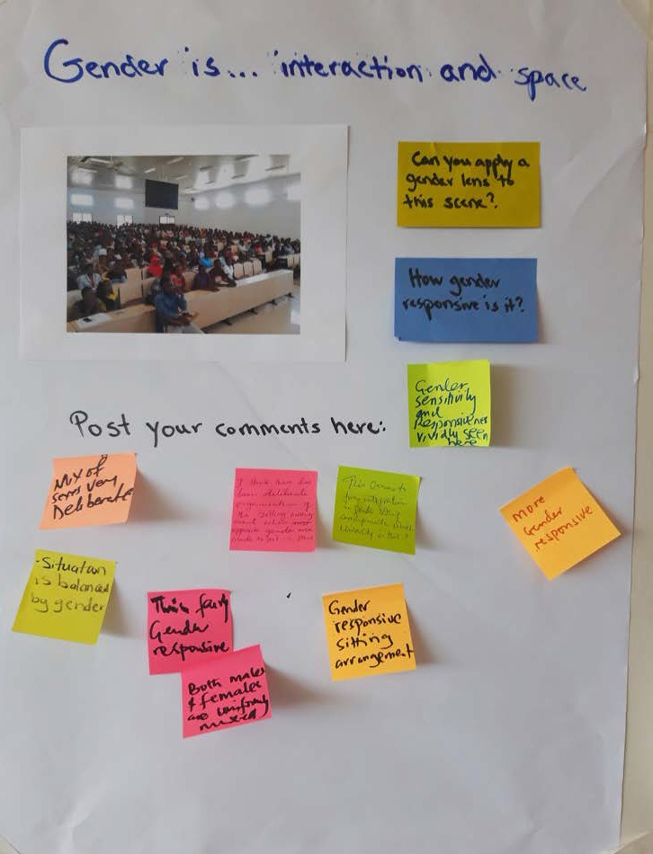

Photos of learning spaces

SESSION: GENDER IS…INTERACTION AND SPACE

Note to workshop facilitator:

In this session participants look at photos of learning spaces. Ideally, you should try to gather these photos from your own institution so that participants are looking at photos of learning spaces that are relevant to them (e.g., a classroom situation). If it is not possible, then the following four example photos of learning spaces could be used instead (images shared by the partner universities within the TESCEA project).

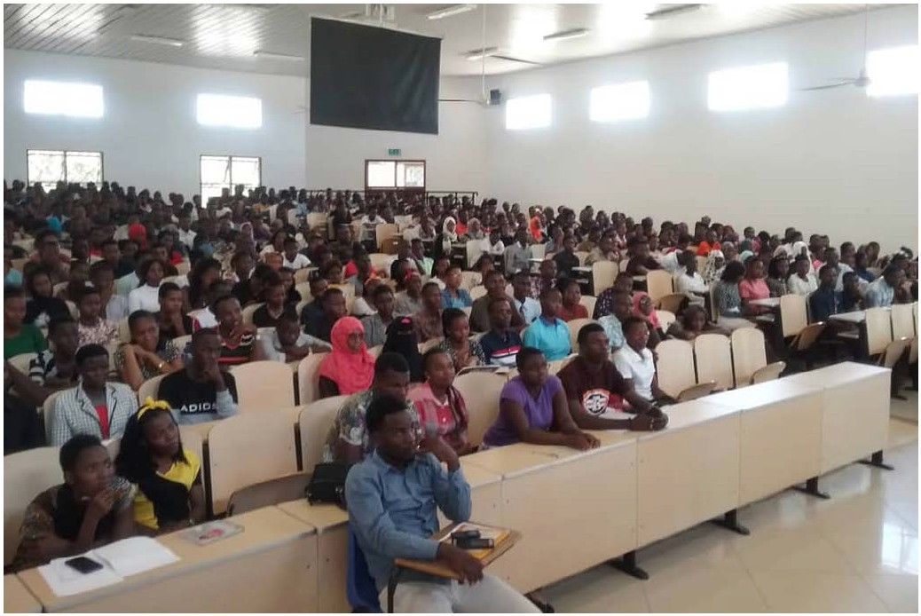

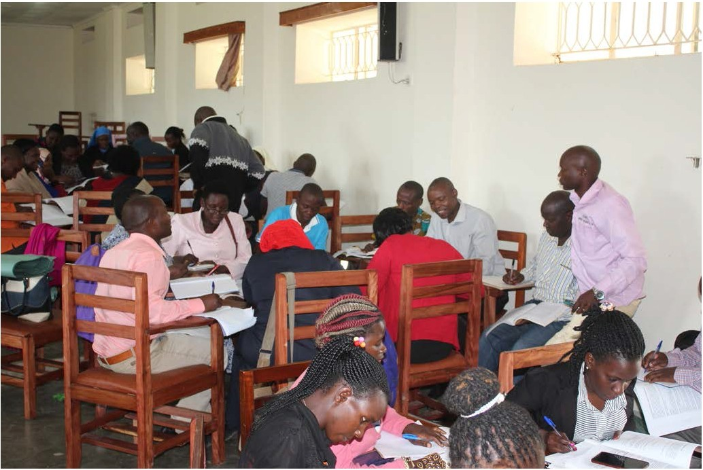

- COURSE REDESIGN DAY 4: TEACHING AND LEARNING STRATEGIES G
-
174

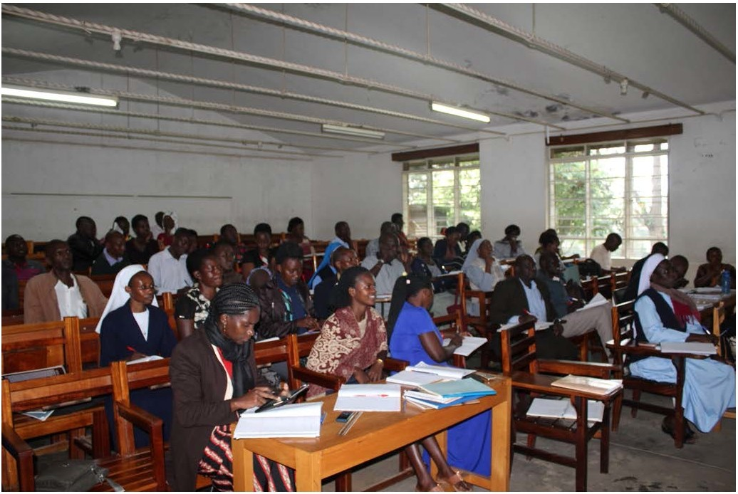

- COURSE REDESIGN DAY 4: TEACHING AND LEARNING STRATEGIES G
-
175

Suggested teaching and learning strategies matched to the key skills headings

SESSION: SELECTING TEACHING AND LEARNING STRATEGIES TO LEARN AND PRACTISE SOFT SKILLS

Note to workshop facilitator:

In this session, participants are asked to determine three to four different teaching and learning strategies that will enable their students to practise and strengthen the skills, capabilities and dispositions, under each of the key skill headings listed in column one below. They then complete the second column (left blank) in their Participant Handbook. Some suggested teaching and learning strategies matched to the key skills headings are provided below.

DIMENSION
TEACHING AND LEARNING STRATEGIES

FOUNDATIONAL KNOWLEDGE
Building a knowledge base | Self-study, lectures, group discussions, case studies, going to the library/ searching online

APPLICATION
Selecting appropriate information | Flipped classroom, class and group discussion, going to the library/ searching online
Evaluating and interpreting information | Individual work, cases, report writing, peer teaching
Making sound arguments and decisions | Plenary discussion, individual projects, case studies, pitching, debates
Analysing the claims/arguments of others | Class discussion, individual assignments, peer learning, case analysis
Creativity and innovation | Experiments, problem-based projects, simulations, games, exhibitions

INTEGRATION
Interconnected thinking | Field visits, reflective journals, simulations, problem- based case studies
Applying information to personal, social and/or work life | Reflective journals, student portfolios, writing blogs
Networking | Group work, group projects, simulations, field work
Dealing with an uncertain future | Problem-based scenarios, simulations based on future scenarios, guest speakers

HUMAN DIMENSION
Self-management | Individual assignments, group work, flipped classroom
Teamwork | Group work/projects, class presentations, field work
Interpersonal skills | Field work, group work and projects, class presentations, peer teaching
Negotiation and managing conflict | Debates, role play, simulations, group work
Oral and written communication | Writing reports, making presentations, role play, group discussion
Leadership | Group projects, group discussion, role play, case studies, guest speakers

CARING
Social awareness | Field visits, group projects, individual research, media reviews
Commitment to positive social change at the community level | Field visits, group projects and work, internship and community attachment

LEARNING HOW TO LEARN
Self-direction | Flipped classroom, individual research, graphic organisers, self-study
Reflective thinking | Learning journal/reflective journal, critical reflective questioning, group discussion, case studies, tweeting

Presenting your redesigned course as if to a new class of students

SESSION: THE 4PS: PARTICIPANTS, PURPOSE, PAY-OFF AND PROCESS (PLUS GENDER RESPONSIVENESS AND LEVEL OF TRANSFORMATION)

Note to workshop facilitator:

Building on the one-minute explanation of their course on Day 1, in this session participants are now presenting as if to a new class of students on their redesigned course. It takes the form of an improved and longer version of the 4Ps (Participants, Purpose, Process and Pay-off/ Benefit) together with how they plan to make their course more gender responsive and transformative for their students. They base their short presentations on the following questions.
Who are the participants (the students on your course)?

What is the purpose of the course or what will the course enable your students to do?

What is the pay-off or how will your students benefit from being on the course and who will they become?
What was the process of developing your course? (Share the concepts, then pick one concept and share the aligned LOs, the assessment methods/ tasks and TLS/TLA)
In what ways are you making the planning and facilitation of your course gender-responsive? (Remember the notes you’ve made in the ‘Ways to be gender-responsive in the planning and facilitation of my course’ section in the Participant Handbook)
How will the course enable your students to make meaning, to create and innovate, to learn and become the person/s described in the Big Dream for the course but also for them to ultimately transform themselves and their world?

Templates for flip charts

DAY 4 SESSION: INTRODUCING THE CONVERSATIONAL FRAMEWORK AND SIX TYPES OF LEARNING

Note to workshop facilitator:

In this session you need to prepare, in advance, six flip charts with the headings left blank, each listing two example T&L strategies/ activities (some of which have been used at this workshop) under six unnamed learning types. Copy the examples below onto six blank pieces of flip chart.

FLIP CHART 1  [Blank space for heading]  Pre-workshop readings  Facilitator presentations | FLIP CHART 2  [Blank space for heading]  Concept maps  4Cs reading strategy: (connections, challenges, concepts, changes) | FLIP CHART 3  [Blank space for heading]  Think-Ink-Pair-Share  Pyramid discussion
FLIP CHART 4  [Blank space for heading]  Role-play  Lab simulation | FLIP CHART 5  [Blank space for heading]  Authentic task-based group projects  A cross-disciplinary design | FLIP CHART 6  [Blank space for heading]  Design a website  Individual work-based project report

DAY 5 ADDITIONAL FACILITATION GUIDANCE & VISUAL AIDS: FROM COURSE REDESIGN TO LEARNING EXPERIENCE DESIGN

Learning design 1: example feedback on how well the author used the Learning Designer tool to capture the detail of their learning experience

SESSION: EVALUATING LEARNING DESIGNS

Note to workshop facilitator:

In this session, participants are invited to evaluate at least one of two learning designs, created by lecturers using the online Learning Designer tool. They draw on the list of questions (which are in the Participant Handbook) to evaluate how well the author used the tool to capture the details of their learning experience. A sample of feedback given on learning design 1 is provided below.

EVALUATION QUESTION | YOUR NOTES
1. How clear are the course learning outcomes? | Good, all very clear.
2. Do the descriptions of the TLAs match the learning types assigned by the author? | In TLA column 1:  the Collaborate activity shows no signs of being collaborative and is mostly ‘watching’ so should be R-W-L.  In TLA column 2:  The Collaborate activity is just reading, even though they are in different groupings, so should be R-W-L.  The final Practice activity is really more Production of their presentations.
3. Is the balance of learning types used, appropriate given the learning outcomes? | Good, but they are not always correctly assigned, and sometimes under- represent the quality of the design.
4. How effectively does the author use Kolb’s learning cycle and what does the sequence of phases look like? | Taking TLA column 1 as an example, the phases and sequence appear to be organised like this: abstract conceptualisation (factual data is introduced that underpins the topic), concrete experience (which  facilitates sensing and evokes feeling), reflective observation and abstract experimentation (to help students to test out their newfound knowledge.)  It might be a good idea to make it clearer how, during the reflective observation phase, student assumptions and misconceptions about the topic in question are being surfaced. In addition, rather than the first TLA being a textbook reading activity (abstract conceptualisation) an activity is designed to demand more sensory input from the student (i.e., concrete experience) to help them surface their own assumptions and misconceptions about the topic.

5. How accurately has the author used the different features? For example,  if the blended icon has been selected, does the contents of the learning design actually match this? | This is meant to be blended, but the internet is never used, and everything is face-to-face. There is no mention of digital resources.  So, this looks like a classroom-based session. The only digital resource mentioned is video, which may not be made available to students as it is run in the class session, so not blended.  None of the calendar icons are ticked so it is all asynchronous, which does not make sense.
6. How appropriate and clear are the teaching and learning activities and their sequencing? (including student numbers selected and timings for each TLA) | In TLA column 1:  After so much input they may need to have taken some notes to help them discuss the tour experience and also produce their report, so after each R-W-L activity it would be good to have a Practice activity where they make notes that will contribute to making their report.  The first TLA is well structured for engaging students in the application relating to the request for markers.  In TLA column 2:  If the Collaborate activity is actually a R-W-L activity of 25 mins, assume this should be done outside class? Or if in class and they are working together in their groups, the instruction should describe how they are to work together through discussion and preparation of something.  The Discuss activity asks them to write their views of the tests, but they will need some guidance on how to focus their discussion. These tasks are not very clear, as the individual groups (what does that refer to?) have 10 mins each, but the duration is 30 mins. How many tasks does each group have?  In the Produce activity there are several large groups coming together to make a presentation – 10 mins to produce a 10 min presentation does not seem to be enough.  In TLA column 5:  It mentions role modelling, but this is done as part of the facilitator of learning’s presentation.  The Collaborate activity does not explain how they are meant to collaborate – what should they produce together, to achieve what goal?  The Practice activity is all part of the same Collaborate activity, and does give some sense of what they should aim for. But then there is no follow-through activity where the chosen students actually present their handling of the case to the class – this would be an additional Production activity.  28 is a very large group to be collaborating. It would be better to stay in smaller groups and agree how to write a plan for their case, which they post to a Google Doc. The facilitator of learning can then discuss some of the responses with the whole group.

In TLA column 6:

The Produce activity should be size 1 as it is individual.

The Discuss activity is interesting but not sure how it works. It seems to cover more than just discussion as it seems to be collaborative. But what happens to what they write? Do they get feedback?
7. How gender responsive is the learning design? | The size of class has not been disaggregated by male and female.  In TLA columns 2-4:  In the Produce activity there is mention of the group leaders and secretaries for each group being both female and male i.e., if the leader is female then the vice must be male and vice versa.  In the Practice activity, two students, one male and one female will present.  In TLA column 5:  In the Collaborate activity there is mention of a case involving a ‘pregnant’ who is unwilling to have a liver function test.
8. How aligned are the learning outcomes, assessment and teaching and learning activities? | The outcomes are quite well aligned with the activities, and there should be enough negotiating in the collaboration tasks to enable students to critique as well as apply what they know.  For the assessment many of the tasks are assessable by the facilitator of learning as students present. There seems to be no final formative  assessment except as feedback to the facilitator of learning, but that’s ok, given the other opportunities.
9. What other observations do you have? | The learning design is detailed and thoughtful. It shows how the patterns of each TLA can be repeated, and then build on in the final two sessions.

Source: Diana Laurillard, Professor of Learning with Digital Technology

Pitching your redesigned course as if to a new class of students or important stakeholders

SESSION: COURSE REDESIGN SHOWCASE THREE-MINUTE PITCH

Note to workshop facilitator:

Building on their 4Ps presentation of their course on Day 4, in this session participants are now pitching their redesigned course as if to a new class of students and/or to important stakeholders. It takes the form of a succinct and convincing three-minute pitch, based on the same questions as before.

Who are the participants (the students on your course)?

What is the purpose of the course or what will the course enable your students to do?

What is the pay-off or how will your students benefit from being on the course and who will they become?
What was the process of developing your course? (share the concepts, then pick one concept and share the aligned LOs, the assessment methods/ tasks and TLS/TLA)
In what ways are you making the planning and facilitation of your course gender- responsive? (Remember the notes you’ve made in the ‘Ways to be gender-responsive in the planning and facilitation of my course’ section in the Participant Handbook)
How will the course enable your students to make meaning, to create and innovate, to learn and become the person/s described in the Big Dream for the course but also for them to ultimately transform themselves and their world?

APPENDICES

APPENDIX A: EXAMPLE WORKSHOP FACILITATOR SCHEDULE FOR A FIVE-DAY COURSE REDESIGN WORKSHOP

DAY 1: CONCEPT MAPPING

Learning outcomes

By the end of Day 1, participants will be able to:

- Conceptualise their course content using a graphic organiser to visualise meaningful relationships among concepts.
- Draft at least one SMART(TT) learning outcome for one of their course concepts.

- Identify how gender might manifest itself in their course content.

TIME | SESSION TITLE | KEY ACTIVITIES | KEY LEARNING POINT(S) OR OUTPUT(S)
8.30 | Welcome and Introductions | Introductions, ways of working and housekeeping  Overview of the workshop and learning outcomes  Results of needs assessment | Participants have a clear understanding of the design & learning-centred approach which underpins the CR workshop  Participants appreciate the level of commitment & participation required to successfully complete the workshop
9.10 | Whistle stop review of transformative learning | Capturing key points from Transformative Learning workshop  Links between transformative learning and course redesign | Importance of redesigning courses to enable students to make meaning, to create and innovate and to ultimately be transformed.
9.40 | Gender is…equality/ equity | Reflection on your own education through a gender lens  Gender audits of male/ female ratios in programmes | Educational settings can teach students about gender differences both explicitly and implicitly  Gender audits of male/female ratios in each programme
10.25 | Compulsory reading: How people learn | Review and discussion of reading guided by questions | Conceptualising content when redesigning courses  Applying a metacognitive approach in the design of courses  Considering students’ pre- existing knowledge in the design of courses
10.55 | BREAK
11.10 | An introduction to the Course Redesign workshop and concept mapping  [move to break-out groups] | Presentation on structure of Course Redesign workshop  Bullet-pointing content of course you plan to redesign  Demonstration of concept mapping | Structure of the course redesign workshop  Differences between a concept and a topic  Course redesign process using concept mapping
12.10 | Development of participant concept maps | One-minute explanation of your course  Developing a concept map for your course | Conceptualising course content as concepts not topics  Adopting a holistic view of courses
13.30 | LUNCH

TIME | SESSION TITLE | KEY ACTIVITIES | KEY LEARNING POINT(S) OR OUTPUT(S)
14.30 | Presentation of participant concept maps | Presentation of your concept map  Give and receive feedback from peers and facilitators | Feedback on the conceptualization of course content
15.45 | Personal reflection | Reflection on what you have learnt so far  Completing your Evidence Document for Programme Alignment, Transformative Learning & Course Redesign | Uncovering assumptions about the content of their courses  Challenging own beliefs and values about the content of their courses  Importance of growing professionally as facilitators of learning
16.00 | Introduction to LO | Presentation on the different levels of LO  Developing a draft LO for one of your course concepts | Drafting of learning outcome(s) for a concept that are SMART(TT)
17.00 | Preparation for day 2 and evaluation of day 1 | Parking lot of Course Redesign workshop TLS  What you need to prepare for Day 2  Formative evaluation of day 1 | The TLS/TLA used to support participant learning on Day 1  Clarity on what to expect from sessions on Day 2 and what preparation is necessary  Reactions to the learning experience on day 1
17.20 | END OF DAY
60 MINS | Facilitation team debrief meeting and preparation for the next day

Preparation for Day 2

Go through the workshop schedule for Day 2 for e.g., the facilitation notes and slides, the compulsory reading (including sending out a text/WhatsApp to remind participants), the required printing of handouts and any extra assigned readings, who should be the lead facilitator and co- facilitators for what sessions and how the sessions will be facilitated.
Facilitators of the Day 2 workshop sessions should prepare in the evening. At the facilitation team meeting the following morning at 8.00 a.m., they should share how they are going to facilitate the sessions (the whole group sessions in particular) and anything new that they thought of the previous evening.
It is recommended that facilitators watch the short video, which shows the use of probing questions to offer feedback to participants on their course learning outcomes. This has been produced for workshop facilitators to watch as part of their preparation for Day 2. The link can be found in the ‘Table of videos and instructions’ section in the introductory facilitation guidelines.

DAY 2: LEARNING OUTCOMES

Learning outcomes

By the end of Day 2, participants will be able to:

- Articulate hard and soft skills learning outcomes that are consistent with the concepts in their course concept map.
- Incorporate gender into at least one of the learning outcomes related to the concepts in their course concept map.
- Develop high-order learning outcomes, for their course concepts, in line with the six dimensions of learning as outlined in the Taxonomy of Significant Learning (TSL) soft skills matrix.

TIME | SESSION TITLE | KEY ACTIVITIES | KEY LEARNING POINT(S) OR OUTPUT(S)
8.30 | Summary of formative evaluation from day 1 | Results from Day 1 formative evaluation | Participants are confident that the workshop facilitators are responding to feedback and are making appropriate adjustments to the workshop schedule.
8.45 | Gender is… stereotypes and (conscious/  unconscious) bias | Gender audit of relevant industry  Individual reflection on audit results | Gender stereotypes and bias have real world impacts  Facilitators of learning should make a conscious effort to examine their own stereotypes and unconscious bias in  order to prevent these from disadvantaging one group of students over another
9.30 | Compulsory reading: Taxonomy of Significant Learning (TSL) | Review of reading and discussion through identifying key ideas | Participants are motivated to draw on the six kinds (or  dimensions) of learning in the TSL, when developing their course-level LO
10.40 | BREAK
11.00 | TSL (soft) skills matrix | An introduction to the TSL (soft) skills matrix  Crafting LO that incorporate soft skills | Importance of LO which inculcate the soft skills outlined in the  ideal university graduate profile, especially those associated with critical thinking and problem- solving.
11.30 | Moving from concept map to LO  [move to break-out groups] | Demonstration of moving from concept map to crafting LO | Participants gain an initial understanding of crafting course LOs through a demonstration on the process of crafting LOs.
11.45 | Crafting SMART(TT) LO aligned to course concepts | Drafting LO for your course  Give and receive feedback from peers & facilitators | SMART(TT) LO aligned to course concepts, need to cut across the six dimensions of learning and the accompanying soft skills outlined in the TSL skills matrix.
13.15 | LUNCH
14.15 | Presentation of revised concept maps and LO | Presentation of your concept map and LO | Importance of hard and soft skills LO that are SMART(TT)

TIME | SESSION TITLE | KEY ACTIVITIES | KEY LEARNING POINT(S) OR OUTPUT(S)
15.15 | Personal reflection | Reflection on what you have learnt so far  Completing your Evidence Document for Programme Alignment, Transformative Learning & Course Redesign | Uncovering assumptions about student learning (learning outcomes)  Challenging own beliefs and values about student learning  Importance of growing professionally as facilitators of learning (reflective practice)
15.30 | Integrating assessment into the course | Short presentation to introduce assessment  Reflection on quotes about assessment | Assessment is important in students’ learning as it defines, signals and prompts what students should learn and how they should learn.
16.00 | Formative and summative assessment | Summing up formative and summative assessment | Assessment is not just about testing but learning.  Use and benefits of formative assessment
16.30 | Preparation for day 3 and evaluation of day 2 | Parking lot of workshop TLS  What you need to prepare for Day 3  Formative evaluation of day 2 | The TLS/TLA used to support participant learning on Day 2  Clarity on what to expect from sessions on Day 3 and what preparation is necessary  Reactions to the learning experience on day 2
16.55 | END OF DAY
60 MINS | Facilitation team debrief meeting and preparation for the next day

Preparation for Day 3

Go through the workshop schedule for Day 3 for e.g., the facilitation notes and slides, the compulsory reading (including sending out a text/WhatsApp to remind participants), the required printing of assigned readings, who should be the lead facilitator and co-facilitators for what sessions and how the sessions will be facilitated.
Facilitators of the Day 3 workshop sessions should prepare in the evening. At the facilitation team meeting the following morning at 8.00 a.m., they should share how they are going to facilitate the sessions (the whole group sessions in particular) and anything new that they thought of the previous evening.

DAY 3: ASSESSMENT

Learning outcomes

By the end of Day 3, participants will be able to:

- Determine formative assessment methods or tasks for their course that promote the learning of male and female students.
- Design a forward-looking assessment task that is gender-responsive and supports the learning of both female and male students.
- Evaluate a rubric that can be used to promote peer and self-assessment.

TIME | SESSION TITLE | KEY ACTIVITIES | KEY LEARNING POINT(S) OR OUTPUT(S)
8.30 | Summary of formative evaluation from day 2 | Results from Day 2 formative evaluation | Participants are confident that the workshop facilitators are noting their points for clarification and making appropriate adjustments to the schedule, in order to address them.
8.45 | Gender is… internalised bias | Feedback scenarios  Reflection on implications for the workplace | Bias can be internalised and make people biased about their own gender  Facilitators of learning should aim to be gender responsive in their feedback to students
9.30 | Assessing for understanding | Identifying a common theme related to rules of assessment | Use of assessment ‘for’ and ‘as’ learning  Providing effective feedback (by facilitator of learning, peers and self)
10.15 | BREAK
10.35 | An Introduction to Educative Assessment | Presentation on Educative Assessment  Converting a backward- looking to a forward-looking assessment task  Introduction to rubrics and how to use them for self- and peer-assessment | Participants create a forward- looking assessment task  Participants appreciate how useful assessment tools such as rubrics are in enabling students to conduct peer- and self- assessment
11.20 | Moving from LO to assessment  [move to break-out groups] | Demonstration of moving from LO to the course assessment plan | Importance of alignment of assessments to LO
11.35 | Development of course assessment plans | Developing your course assessment plan  Give and receive feedback from peers & facilitators | How to align formative and summative assessment tasks to LO  An assessment plan that has both formative and summative assessments
13.00 | LUNCH
14.00 | Development of course assessment plans cont. | Finalise your course assessment plan | See above
14.15 | Presentation of course assessment plans | Presentation of your course assessment plan | Constructive feedback on course assessment plans

TIME | SESSION TITLE | KEY ACTIVITIES | KEY LEARNING POINT(S) OR OUTPUT(S)
15.15 | Personal reflection | Reflection on what you have learnt so far  Completing your Evidence Document for Programme Alignment, Transformative Learning & Course Redesign | Uncovering assumptions about assessments  Challenging own beliefs and values about assessments  Importance of growing professionally as facilitators of learning (reflective practice)
15.30 | Moving from LO to TLS | Clustering TLS under three approaches to teaching  Pooling TLS you use in your courses  Short presentation on Constructive Alignment (CA) | Theories of teaching/ approaches to teaching  Pooled list of teaching and learning strategies used by participants on their courses  The importance of aligning TLS to LOs
16.30 | Preparation for day 4 and evaluation of day 3 | Parking lot of workshop TLS  What you need to prepare for Day 4  Formative evaluation of day 3 | The TLS/TLA used to support participant learning on Day 3  Clarity on what to expect from sessions on Day 4 and what preparation is necessary  Reactions to the learning experience on day 3
16.50 | END OF DAY
60 MINS | Facilitation team debrief meeting and preparation for the next day

Preparation for Day 4

Go through the workshop schedule for Day 4 for e.g., the facilitation notes and slides, the compulsory reading (including sending out a text/WhatsApp to remind participants), who should be the lead facilitator and co-facilitators for what sessions and how the sessions will be facilitated.
Remind the co-facilitator who was writing up the Final list of teaching & learning strategies that they should add any new strategies to this list from the rolling ‘Parking lot of workshop T&L strategies/activities’ flip chart (compiled Days 1-3). Make sure that this is finished before the first session on Day 4 and that it is posted on the wall or board in the main room in the morning.
Facilitators of the Day 4 workshop sessions should prepare in the evening. At the facilitation team meeting the following morning at 8.00 a.m., they should share how they are going to facilitate the sessions (the whole group sessions in particular) and anything new that they thought of the previous evening.

DAY 4: TEACHING AND LEARNING STRATEGIES

Learning outcomes

By the end of Day 4, participants will be able to:

- Select teaching and learning strategies that enable both female and male students to achieve course learning outcomes, take control of their learning (i.e., through
a metacognitive approach) and form the habit of critical reflective thinking.

- Organise teaching and learning spaces and interactions that enable both female and male students to participate and benefit equally from the learning.
- Draft a university course outline, drawing on the evidence they have gathered through their participation in the Programme Alignment, Transformative Learning and Course Redesign workshops.

TIME | SESSION TITLE | KEY ACTIVITIES | KEY LEARNING POINT(S) OR OUTPUT(S)
8.30 | Summary of formative evaluation from day 3 | Results from Day 3 formative evaluation | Participants can vary what they evaluate by focusing on both cognitive and affective domains.  Formative evaluations can be designed in such a way that the results can be disaggregated by gender so that facilitators of learning can identify whether there are any differences between male and female  participant responses and follow- up on why this might be.
8.45 | Gender is… interaction and space | Reviewing photos of learning spaces though a gender lens  Reflection on how male and female students can benefit equally from learning | Gender responsive teaching and learning spaces enable both female and male students to participate and benefit equally from the learning  Facilitators of learning have a responsibility to ensure that both female and male students are able to participate in and benefit equally from their course
9.30 | Compulsory reading: Unpacking thinking | Review of reading guided by questions  Connecting ideas between the workshop readings | Making students’ thinking visible by encouraging them to think about thinking, through the use of the Understanding Map
10.30 | BREAK
10.50 | Selecting TLS to learn and practise soft skills | Determining TLS that develop the skills, dispositions and capabilities outlined in TSL (soft) skills matrix | Alignment of TLS to the headline skills stipulated in the TSL (soft) skills matrix
11.25 | Moving from course LO to TLS  [move to break-out groups] | Demonstration of moving from course LO to TLS | Alignment of TLS to LO Examples of TLS

TIME | SESSION TITLE | KEY ACTIVITIES | KEY LEARNING POINT(S) OR OUTPUT(S)
11.40 | Selecting TLS aligned to LO | Selecting TLS that meet your course LO  Give and receive feedback from peers & facilitators  Starting to transfer key information from your Evidence Document for Programme Alignment, Transformative Learning & Course Redesign to your university course outline template. | TLS that support course LO and include a range of different kinds of learning and their associated skills, capabilities and dispositions
13.00 | LUNCH
14.00 | The 4Ps: Participants, Purpose, Pay-off and Process (plus gender responsiveness  and level of transformation) | Presentations of the 4Ps plus how your course is gender responsive and transformative. | Promoting courses to beneficiaries in a succinct and convincing way
14.30 | Personal reflection | Reflection on what you have learnt so far  Completing your Evidence Document for Programme Alignment, Transformative Learning & Course Redesign | Uncovering assumptions about teaching and learning strategies  Challenging own beliefs and values on teaching and learning strategies  Importance of growing professionally as facilitators of learning (reflective practice)
14.40 | Introducing the Conversational Framework and six types of learning | Video on The Conversational Framework  Posting teaching and learning strategies and activities under the six types of learning | A framework that participants can use in designing students’ learning at the class or session level  The importance of structuring students’ learning using a balance of the six types of learning as stipulated in the framework
15.40 | Transformative Learning Cycle refresher | Discussion on the Transformative Learning Cycle & Kolb’s Reflective Learning Cycle  Redesign of a single learning session following the Transformative Learning Cycle | A redesigned 2–3-hour learning session based on the Transformative Learning cycle

TIME | SESSION TITLE | KEY ACTIVITIES | KEY LEARNING POINT(S) OR OUTPUT(S)
16.25 | Preparation for day 5 and evaluation of day 4 | What you need to prepare for Day 5  Formative evaluation of day 4 | Clarity on what to expect from sessions on Day 5 and what preparation is necessary  Reflections on the learning experience so far with the help of the course redesign concept map
16.45 | END OF DAY
60 MINS | Facilitation team debrief meeting and preparation for the next day

Preparation for Day 5

Go through the workshop schedule for Day 5 for e.g., the facilitation notes and slides, the required printing, who should be the lead facilitator and co-facilitators for what sessions and how the sessions will be facilitated.
One of the facilitators should check-in and confirm the attendance of individuals such as the DVC of Academic Affairs, the respective Deans/HODs of participants and student leaders if they have been invited to attend the course redesign showcase pitch session in the afternoon.
If certificates are to be awarded, ensure they are printed and signed before lunchtime tomorrow, so they can be handed out in the final session.
As good practice dictates, it is strongly recommended that both participants and workshop facilitators complete a workshop evaluation so that the findings can inform and improve the delivery of future CR workshops. A suggested template has been included in Appendix J of the FRP but remember this is just a template. It needs to be tailored to the context and meet the information needs of the facilitation team and other relevant stakeholders. The evaluation can be conducted using a hardcopy form or an online survey in the final session.
Facilitators of the Day 5 workshop sessions should prepare in the evening. At the facilitation team meeting the following morning at 8.00 a.m., they should share how they are going to facilitate the sessions (the whole group sessions in particular) and anything new that they thought of the previous evening.

DAY 5: FROM COURSE TO LEARNING EXPERIENCE DESIGN

Learning outcomes

By the end of Day 5, participants will be able to:

- Evaluate learning designs based on the six types of learning in the Conversational Framework.
- Capture and share what they have developed so far in their redesigned course using the online Learning Designer tool.
- Pitch their redesigned course to students and stakeholders in a succinct, convincing and engaging way.
- Articulate how they will be making the planning and facilitation of their redesigned course more gender responsive going forward.

TIME | SESSION TITLE | KEY ACTIVITIES | KEY LEARNING POINT(S) OR OUTPUT(S)
8.30 | Summary of formative evaluation from day 4 | Results from Day 4 formative evaluation | Participants will need to proactively manage their future learning and take responsibility for researching answers to their questions and/or areas  of interest, once outside the workshop.
8.40 | Gender is… power (empowerment): final reflections | Discussion around knowledge and power flows  Reflection on takeaways from the gender sessions | Gender (in)equalities plays into power and knowledge  Reflections on how takeaways from gender sessions are going to inform participants’ teaching and learning practice going forwards
9.25 | Introduction to Learning Designer | Introductory video on the Learning Designer tool  Videos of lecturers sharing their experiences of using the tool. | Participants have a basic understanding of what the online Learning Designer tool is and what are some of the benefits and challenges of using it.
10.00 | BREAK
10.20 | Evaluating learning designs | Evaluating one or two example learning designs on Learning Designer | Participants have a good understanding of what a learning design looks like using the Learning Designer tool and the type and range of detail that is necessary to capture.
11.20 | Learning Designer Taster | Screencast demonstration of using Learning Designer  Trying out Learning Designer, including initial set-up and inputting of information from the Evidence Document for Programme Alignment, Transformative Learning & Course Redesign | Participants can create in Learning Designer an account and a new design; input information related to their redesigned course and can save and share their learning design.
12.20 | Personal reflection | Reflection on what you have learnt so far  Completing your Evidence Document for Programme Alignment, Transformative Learning & Course Redesign  Preparation for course redesign showcase pitch | Uncovering assumptions about the planning and design of learning experiences  Challenging own beliefs and values on the design of learning experiences  Importance of growing professionally as facilitators of learning (reflective practice)

TIME | SESSION TITLE | KEY ACTIVITIES | KEY LEARNING POINT(S) OR OUTPUT(S)
12.40 | LUNCH
13.30 | Course redesign showcase three - minute pitch | Preparing and pitching their redesigned course as if to a new class of students | Promoting courses to students and stakeholders in a succinct, convincing and engaging way
15.00 | The way forward | Overview of the online course called ‘Learning Design - planning effective learning experiences’  Optional awarding of certificates  Workshop evaluation | Participants have a solid understanding of what the online course ‘Learning Design  – planning effective learning experiences’ covers and are motivated to continue their redesign learning journey.
15.45 | END OF DAY
40 MINS | Facilitation team debrief meeting and next steps

APPENDIX B: EXAMPLE PARTICIPANT SCHEDULE FOR A FIVE-DAY COURSE REDESIGN WORKSHOP

Date(s) and Location:

To be completed by workshop facilitators

Overall workshop learning outcomes

By the end of the workshop, you will be able to:

- Conceptualise your course content through the means of a graphic organiser to visualise meaningful relationships among concepts.
- Develop high quality hard and soft skills learning outcomes (LO) that are consistent with the concepts in your course concept map.
- Produce an assessment plan at the course level that is aligned to your course LO.

- Select high quality teaching & learning strategies (TLS) that are aligned to your course LO.

- Integrate a gender dimension into the design, planning and facilitation of your course(s).

Note to workshop facilitators: you might want to insert additional information and a suitable image here.

DAY 1: CONCEPT MAPPING

Learning outcomes

By the end of the day, you will be able to:

- Conceptualise your course content using a graphic organiser to visualise meaningful relationships among concepts.
- Draft at least one SMART(TT) learning outcome for one of your course concepts.

- Identify how gender might manifest itself in your course content.

Key output of Day 1

Course concept map

TIME | SESSION TITLE | KEY ACTIVITIES
8.30 | Welcome and Introductions | Introductions, ways of working and housekeeping Overview of the workshop and learning outcomes  Results of needs assessment
9.10 | Whistle stop review of transformative learning | Capturing key points from Transformative Learning workshop  Links between Transformative Learning and Course Redesign
9.40 | Gender is…equality/equity | Reflection on your own education through a gender lens  Gender audits of male/female ratios in programmes
10.25 | Compulsory reading: How people learn | Review and discussion of reading guided by questions
10.55 | BREAK
11.10 | An introduction to the Course Redesign workshop and concept mapping  [move to break-out groups] | Presentation on structure of Course Redesign workshop Bullet-pointing content of course you plan to redesign  Demonstration of concept mapping
12.10 | Development of participant concept maps | One-minute explanation of your course  Developing a concept map for your course
13.30 | LUNCH
14.30 | Presentation of participant concept maps | Presentation of your concept map  Give and receive feedback from peers and facilitators
15.45 | Personal reflection | Reflection on what you have learnt so far  Completing your Evidence Document for Programme Alignment, Transformative Learning & Course Redesign

TIME | SESSION TITLE | KEY ACTIVITIES
16.00 | Introduction to Learning Outcomes | Presentation on the different levels of Learning Outcome  Developing a draft Learning Outcome for one of your course concepts
17.00 | Preparation for day 2 and evaluation of day 1 | Parking lot of Course Redesign workshop teaching and learning strategies  What you need to prepare for Day 2  Formative evaluation of day 1
17.20 | END OF DAY

Preparation for Day 2

- Look at the Day 2 Learning Outcomes section in your participant handbook for details on what to prepare for tomorrow.
- Continue to refine your concept map and start to develop your learning outcomes. There will be time to work further on them tomorrow morning. Note that the learning outcomes should be
aligned with your concept map – you should be able to explain how the learning outcomes shape and are shaped by your concept map.
- Make sure you have read the compulsory reading, ‘Creating significant learning experiences – Chapter 2 - A Taxonomy of Significant Learning’ and be ready to discuss your thoughts about it tomorrow morning. This is a key text so it’s important that you read it, no summary will be provided during the session.
- Read the recommended reading ‘Think you’re all for gender equality? Your unconscious may have other ideas’ in the ‘Days 1-5: Gender-Responsive Pedagogy’ section of your Participant Handbook for tomorrow’s gender session which will be looking at bias.
- Make sure you have your Programme Alignment and Transformative Learning Participant Handbooks with you throughout all five days of the Course Redesign workshop.

DAY 2: LEARNING OUTCOMES

Learning outcomes

By the end of Day 2, you will be able to:

- Articulate hard and soft skills learning outcomes that are consistent with the concepts in your course concept map.
- Incorporate gender into at least one of the learning outcomes related to the concepts in your course concept map.
- Develop high-order learning outcomes, for your course concepts, in line with the six dimensions of learning as outlined in the Taxonomy of Significant Learning (TSL) soft skills matrix.

Key output of Day 2

Course learning outcomes

TIME | SESSION TITLE | KEY ACTIVITIES
8.30 | Summary of formative evaluation from day 1 | Results from Day 1 formative evaluation
8.45 | Gender is… stereotypes and (conscious/ unconscious) bias | Gender audit of relevant industry  Individual reflection on audit results
9.30 | Compulsory reading: Taxonomy of Significant Learning (TSL) | Review of reading and discussion through identifying key ideas
10.40 | BREAK
11.00 | TSL (soft) skills matrix | An introduction to the TSL (soft) skills matrix  Crafting learning outcomes that incorporate soft skills
11.30 | Moving from concept map to learning outcomes  [move to break-out groups] | Demonstration of moving from concept map to crafting learning outcomes
11.45 | Crafting SMART(TT) LO aligned to course concepts | Drafting learning outcomes for your course  Give and receive feedback from peers & facilitators
13.15 | LUNCH
14.15 | Presentation of revised concept maps and LO | Presentation of your concept map and learning outcomes
15.15 | Personal reflection | Reflection on what you have learnt so far  Completing your Evidence Document for Programme Alignment, Transformative Learning & Course Redesign

TIME | SESSION TITLE | KEY ACTIVITIES
15.30 | Integrating assessment into the course | Short presentation to introduce assessment  Reflection on quotes about assessment
16.00 | Formative and summative assessment | Summing up formative and summative assessment
16.30 | Preparation for day 3 and evaluation of day 2 | Parking lot of workshop teaching and learning strategies What you need to prepare for Day 3  Formative evaluation of day 2
16.55 | END OF DAY

Preparation for Day 3

- Revise and finish your learning outcomes based on the feedback you received in the earlier sessions.

- Begin to think about how you will move from learning outcomes to assessment.

- Make sure you have read the compulsory reading, ‘Fourteen rules for better assessment in higher education – Chapter 10 - Assessing for understanding from the book ‘Learning to teach in higher education’ (2nd edition) by Paul Ramsden and be ready to discuss your thoughts about it tomorrow. Bring a hard or soft copy of the reading with you on Day 3.
- Bring examples of assessment tasks you have used in your courses (ideally in the course you are redesigning) to work with during the sessions the next day.

DAY 3: ASSESSMENT

Learning outcomes

By the end of Day 3, you will be able to:

- Determine formative assessment methods or tasks for your course that promote the learning of male and female students.
- Design a forward-looking assessment task that is gender-responsive and supports the learning of both female and male students.
- Evaluate a rubric that can be used to promote peer and self-assessment.

Key output of Day 3

Course assessment plan and a forward-looking assessment task at the course level

TIME | SESSION TITLE | KEY ACTIVITIES
8.30 | Summary of formative evaluation from day 2 | Results from Day 2 formative evaluation
8.45 | Gender is… internalised bias | Feedback scenarios  Reflection on implications for the workplace
9.30 | Assessing for understanding | Identifying a common theme related to rules of assessment
10.15 | BREAK
10.35 | An Introduction to Educative Assessment | Presentation on Educative Assessment  Converting a backward-looking to a forward-looking assessment task  Introduction to rubrics and how to use them for self- and peer-assessment
11.20 | Moving from LO to assessment  [move to break-out groups] | Demonstration of moving from learning outcomes to the course assessment plan
11.35 | Development of course assessment plans | Developing your course assessment plan  Give and receive feedback from peers & facilitators
13.00 | LUNCH
14.00 | Development of course assessment plans cont. | Finalise your course assessment plan
14.15 | Presentation of course assessment plans | Presentation of your course assessment plan

TIME | SESSION TITLE | KEY ACTIVITIES
15.15 | Personal reflection | Reflection on what you have learnt so far  Completing your Evidence Document for Programme Alignment, Transformative Learning & Course Redesign
15.30 | Moving from LO to TLS | Clustering teaching and learning strategies under three approaches to teaching  Pooling teaching and learning strategies you use in your courses  Short presentation on Constructive Alignment (CA)
16.30 | Preparation for day 4 and evaluation of day 3 | Parking lot of workshop teaching and learning strategies What you need to prepare for Day 4  Formative evaluation of day 3
16.50 | END OF DAY

Preparation for Day 4

- Revise your concept map, learning outcomes and assessment plan, as needed.

- Think about teaching and learning strategies that directly support the learning described in your learning outcomes and which enable student success in assessment.
- Make sure you have read ‘Making Thinking Visible: How to promote engagement, understanding, and independence for all learners – Chapter 1 – Unpacking Thinking’ and be ready to discuss your thoughts about it in the session tomorrow. Concentrate on pages 10-15.
- Tomorrow there will be an activity drawing on all four of the compulsory readings. You will need to bring your completed ‘Notes on reading form’ for each of the readings and soft or hard copies of the Day 2 and Day 3 readings.
- Watch the five-minute video where Diana Laurillard explains the Conversational Framework and the six types of learning so that you familiarise yourselves with the concepts and framework, and are ready to apply them in the sessions on Day 4. The link is in the ‘The Conversational Framework and six learning types’ section of Day 4 in the Participant Handbook.

DAY 4: TEACHING AND LEARNING STRATEGIES

Learning outcomes

By the end of Day 4, you will be able to:

- Select teaching and learning strategies that enable both female and male students to achieve course learning outcomes, take control of their learning (i.e., through
a metacognitive approach) and form the habit of critical reflective thinking.

- Organise teaching and learning spaces and interactions that enable both female and male students to participate and benefit equally from the learning.
- Draft a university course outline, drawing on the evidence you have gathered through your participation in the Programme Alignment, Transformative Learning and Course Redesign workshops.

Key output of Day 4

A list of teaching and learning strategies that are aligned to each course learning outcome.

TIME | SESSION TITLE | KEY ACTIVITIES
8.30 | Summary of formative evaluation from day 3 | Results from Day 3 formative evaluation
8.45 | Gender is…interaction and space | Reviewing photos of learning spaces though a gender lens  Reflection on how male and female students can benefit equally from learning
9.30 | Compulsory reading: Unpacking thinking | Review of reading guided by questions  Connecting ideas between the workshop readings
10.30 | BREAK
10.50 | Selecting teaching and learning strategies to learn and practise soft skills | Determining teaching and learning strategies that develop the skills, dispositions and capabilities outlined in TSL (soft) skills matrix
11.25 | Moving from course learning outcomes to teaching and learning strategies  [move to break-out groups] | Demonstration of moving from course learning outcomes to teaching and learning strategies
11.40 | Selecting teaching and learning strategies aligned to learning outcomes | Selecting teaching and learning strategies that meet your course learning outcomes  Give and receive feedback from peers & facilitators  Starting to transfer key information from your Evidence Document for Programme Alignment, Transformative Learning & Course Redesign to your university course outline template.
13.00 | LUNCH

TIME | SESSION TITLE | KEY ACTIVITIES
14.00 | The 4Ps: Participants, Purpose, Pay-off and Process (plus gender responsiveness and level of transformation) | Presentations of the 4Ps plus how your course is gender responsive and transformative.
14.30 | Personal reflection | Reflection on what you have learnt so far  Completing your Evidence Document for Programme Alignment, Transformative Learning & Course Redesign
14.40 | Introducing the Conversational Framework and six types of learning | Video on The Conversational Framework  Posting teaching and learning strategies and activities under the six types of learning
15.40 | Transformative Learning Cycle refresher | Discussion on the Transformative Learning Cycle & Kolb’s Reflective Learning Cycle  Redesign of a single learning session following the Transformative Learning Cycle
16.25 | Preparation for day 5 and evaluation of day 4 | What you need to prepare for Day 5  Formative evaluation of day 4
16.45 | END OF DAY

Preparation for Day 5

- Continue to work on your university course outlines.

- You will need to use your laptops tomorrow morning (or at least be able to share one between two participants) to evaluate learning designs online. You might also find some headphones useful to watch videos on your laptops (if the bandwidth is strong enough).
- Watch the videos ‘Introduction to Learning Designer’ and ‘the Learning Designer Guide’ in advance of the morning sessions, both links are under the section ‘Designing effective learning experiences‘ in Day 5 of the Participant Handbook.
- Prepare and be ready to give your three-minute course design showcase pitch tomorrow afternoon.

DAY 5: FROM COURSE TO LEARNING EXPERIENCE DESIGN

Learning outcomes

By the end of Day 5, you will be able to:

- Evaluate learning designs based on the six types of learning in the Conversational Framework.
- Capture and share what you have developed so far in your redesigned course using the online Learning Designer tool.
- Pitch your redesigned course to students and stakeholders in a succinct, convincing and engaging way.
- Articulate how you will be making the planning and facilitation of your redesigned course more gender responsive going forward.

Key output of Day 5

A draft learning design to work on further.

Key materials to make a successful course redesign showcase pitch.

TIME | SESSION TITLE | KEY ACTIVITIES
8.30 | Summary of formative evaluation from day 4 | Results from Day 4 formative evaluation
8.40 | Gender is… power (empowerment): final reflections | Discussion around knowledge and power flows  Reflection on takeaways from the gender sessions
9.25 | Introduction to Learning Designer | Introductory video on the Learning Designer tool  Videos of lecturers sharing their experiences of using the tool.
10.00 | BREAK
10.20 | Evaluating learning designs | Evaluating one or two example learning designs on Learning Designer
11.20 | Learning Designer Taster | Screencast demonstration of using Learning Designer  Trying out Learning Designer, including initial set-up and inputting of information from the Evidence Document for Programme Alignment, Transformative Learning & Course Redesign
12.20 | Personal reflection | Reflection on what you have learnt so far  Completing your Evidence Document for Programme Alignment, Transformative Learning & Course Redesign  Preparation for course redesign showcase pitch
12.40 | LUNCH

TIME | SESSION TITLE | KEY ACTIVITIES
13.30 | Course redesign showcase three - minute pitch | Preparing and pitching their redesigned course as if to a new class of students
15.00 | The way forward | Overview of the online course called ‘Learning Design - planning effective learning experiences’  Optional awarding of certificates  Workshop evaluation
15.45 | END OF DAY

APPENDIX C: NEEDS ASSESSMENT QUESTIONNAIRE FOR ACADEMIC TEACHING STAFF

Please email us your completed questionnaire and the course outline for the course you plan to redesign, at least one week in advance of the workshop to: [workshop facilitator to insert return email address]
The purpose of this needs assessment questionnaire is:

Firstly, to provide the workshop facilitators with information on the participants, to assist them in the planning and facilitation of the workshop and in the grouping of participants during the sessions. The groups in the breakout sessions need to be made up of academic teaching staff who: have differing years of teaching experience, are from different disciplines and are a mix of both male and female participants.
Secondly, to enable participants to reflect on the course they are planning to redesign, in advance of the course redesign for significant learning and transformation workshop.

- DEMOGRAPHIC INFORMATION

NAME:
GENDER (M/F):
EMAIL ADDRESS:
DESIGNATION/ JOB TITLE:
FACULTY:
DEPARTMENT:
COURSES AND PROGRAMMES THAT YOU HAVE TAUGHT ON:

- GENERAL INFORMATION

- What is the average class size of the courses that you have taught on?

  - 100+ students

  - 50-100 students

  - 20-50 students

  - less than 20 students

- How many years of university teaching experience do you have?

- COURSE YOU PLAN TO REDESIGN

- Please provide a paragraph describing the course you have chosen to focus on during the course redesign workshop. Remember to include the name and duration of the course.

- Have you taught this course before? Yes / No

If yes, how many times?

- Approximately how many students are expected to enrol on this course?

- Briefly describe your students’ profile (part-time/full-time, employed/unemployed, technical knowledge, socio-economic background, etc.)

- Please describe the teaching and learning setting (e.g., large class, seminar, clinical teaching etc.)

- In order of importance, list what you have expected or will expect students to learn from this course.

- What soft skills do you expect students to acquire and develop in this course?

- What are some of the gender aspects that may constrain or enable the learning of your students?

- What teaching and learning strategies have you used, or would you like to use in the course?

- How have you assessed or how are you thinking of assessing student learning in this course?

- On a scale of 1-10, where 1 is low and 10 is high, how would you rate the following in the context of the course you are redesigning? Insert a X in the relevant box below.

Please don’t insert more than 1 answer (i.e., X) per row.

 | 10 | 9 | 8 | 7 | 6 | 5 | 4 | 3 | 2 | 1
Your knowledge of the subject matter in this course?
Your knowledge of teaching/ facilitating learning in this course?
Your knowledge of how
students learn in this course/ discipline?

- Describe any concerns you have related to teaching/ facilitating learning (e.g., speaking in front of a large group, deciding what to include in your course, how to get students to think etc.).

- What do you (as a facilitator of learning) expect to get out of this workshop?

Thank you. Your responses will help us in the planning stages of the Course Redesign for Significant Learning and Transformation workshop.

APPENDIX D: NOTES ON READING FORM

The purpose of this form is to capture your key reflections, as you read through each of the assigned readings. The contents of this form will support your overall learning during the five days of the course redesign for significant learning and transformation workshop and you will be expected to apply what you have learnt to the session activities you participate in. This will also make a useful addition to your teaching portfolio (if you maintain one) and you might want to share its contents with your colleagues.
Complete this form (one form per compulsory reading) in soft copy and in advance
of the workshop day where the reading will be examined in more depth.

Author and title:

Key ideas:

Questions I have about the reading:

Ways the key ideas relate to the redesign of my course:

Continue overleaf

APPENDIX I: PERSONAL REFLECTION FORM

Personal reflection leads us to make meaning from our learning experiences. It helps us to understand the significance of those experiences to us personally on our journey to being better facilitators
of learning. Reflection also helps us uncover assumptions we have about teaching and our work as facilitators of learning. This provides us with the evidence to evaluate those assumptions so that we can then challenge our beliefs and values and therefore continue to grow and learn.
The purpose of this daily personal reflection is to help you critically reflect over what has been happening in the workshop and in any readings, as it pertains to your life and your experiences throughout the workshop. Enter your comments as reflections on your reactions to what you have encountered,
rather than simply summaries of what took place in the workshop or in the reading assignments.

Complete the form in soft copy, one form for each day of the workshop. The following questions are here to help guide your reflection:

TITLE OF COURSE UNDER REDESIGN: |  |  | REFLECTIONS FOR DAY NO.
QUESTION |  | RESPONSE
What new learning did I experience during today’s sessions and activities?
What did I learn about myself as a learner as I worked through the sessions and activities?
How did my work in today’s sessions and activities challenge my beliefs and values about my teaching?
What assumptions did I uncover?

What evidence do I need to gather to (in)validate these assumptions?
Additional thoughts/insights |  | Continue overleaf

Briefly explain how you intend to improve students’ learning after this workshop in relation to transformative learning and gender responsiveness. Provide some examples:

Please share any suggestions for improvement for similar workshops in the future:

Any other comments:

APPENDIX J: COURSE REDESIGN WORKSHOP EVALUATION TEMPLATE

Thank you for your participation in the course redesign for significant learning and transformation workshop. We would appreciate your anonymous feedback to continually improve what we do.

STATEMENTS |  | Strongly Agree | Agree | Neither agree nor disagree | Disagree | Strongly Disagree
1. | My expectations of this workshop were met.
2. | The workshop achieved its objectives.
3. | The workshop was well organised.
4. | The workshop was useful in terms of my professional development.
5. | I would recommend this workshop to my colleagues.
6. | I have a deeper understanding of course design that I will use for other courses.
7. | Presentation in the whole group prepared me to work on different design elements of my course.
8. | Facilitation in the small breakout rooms was productive for me.
9. | I am able to apply the skills in the Taxonomy of Significant Learning (soft) skills matrix.
10. | I am able to integrate Gender- Responsive Pedagogy in my course.

Briefly explain how you intend to improve students’ learning after this workshop in relation to transformative learning and gender responsiveness. Provide some examples:

Please share any suggestions for improvement for similar workshops in the future:

Any other comments:

